EE 210

HW#: 05

Last Name: **Aldacher**

First Name: **Muhammad**

ID: **011510317**

Date: **10/3/2020**

Assigned question #s: **2**

**Q1**

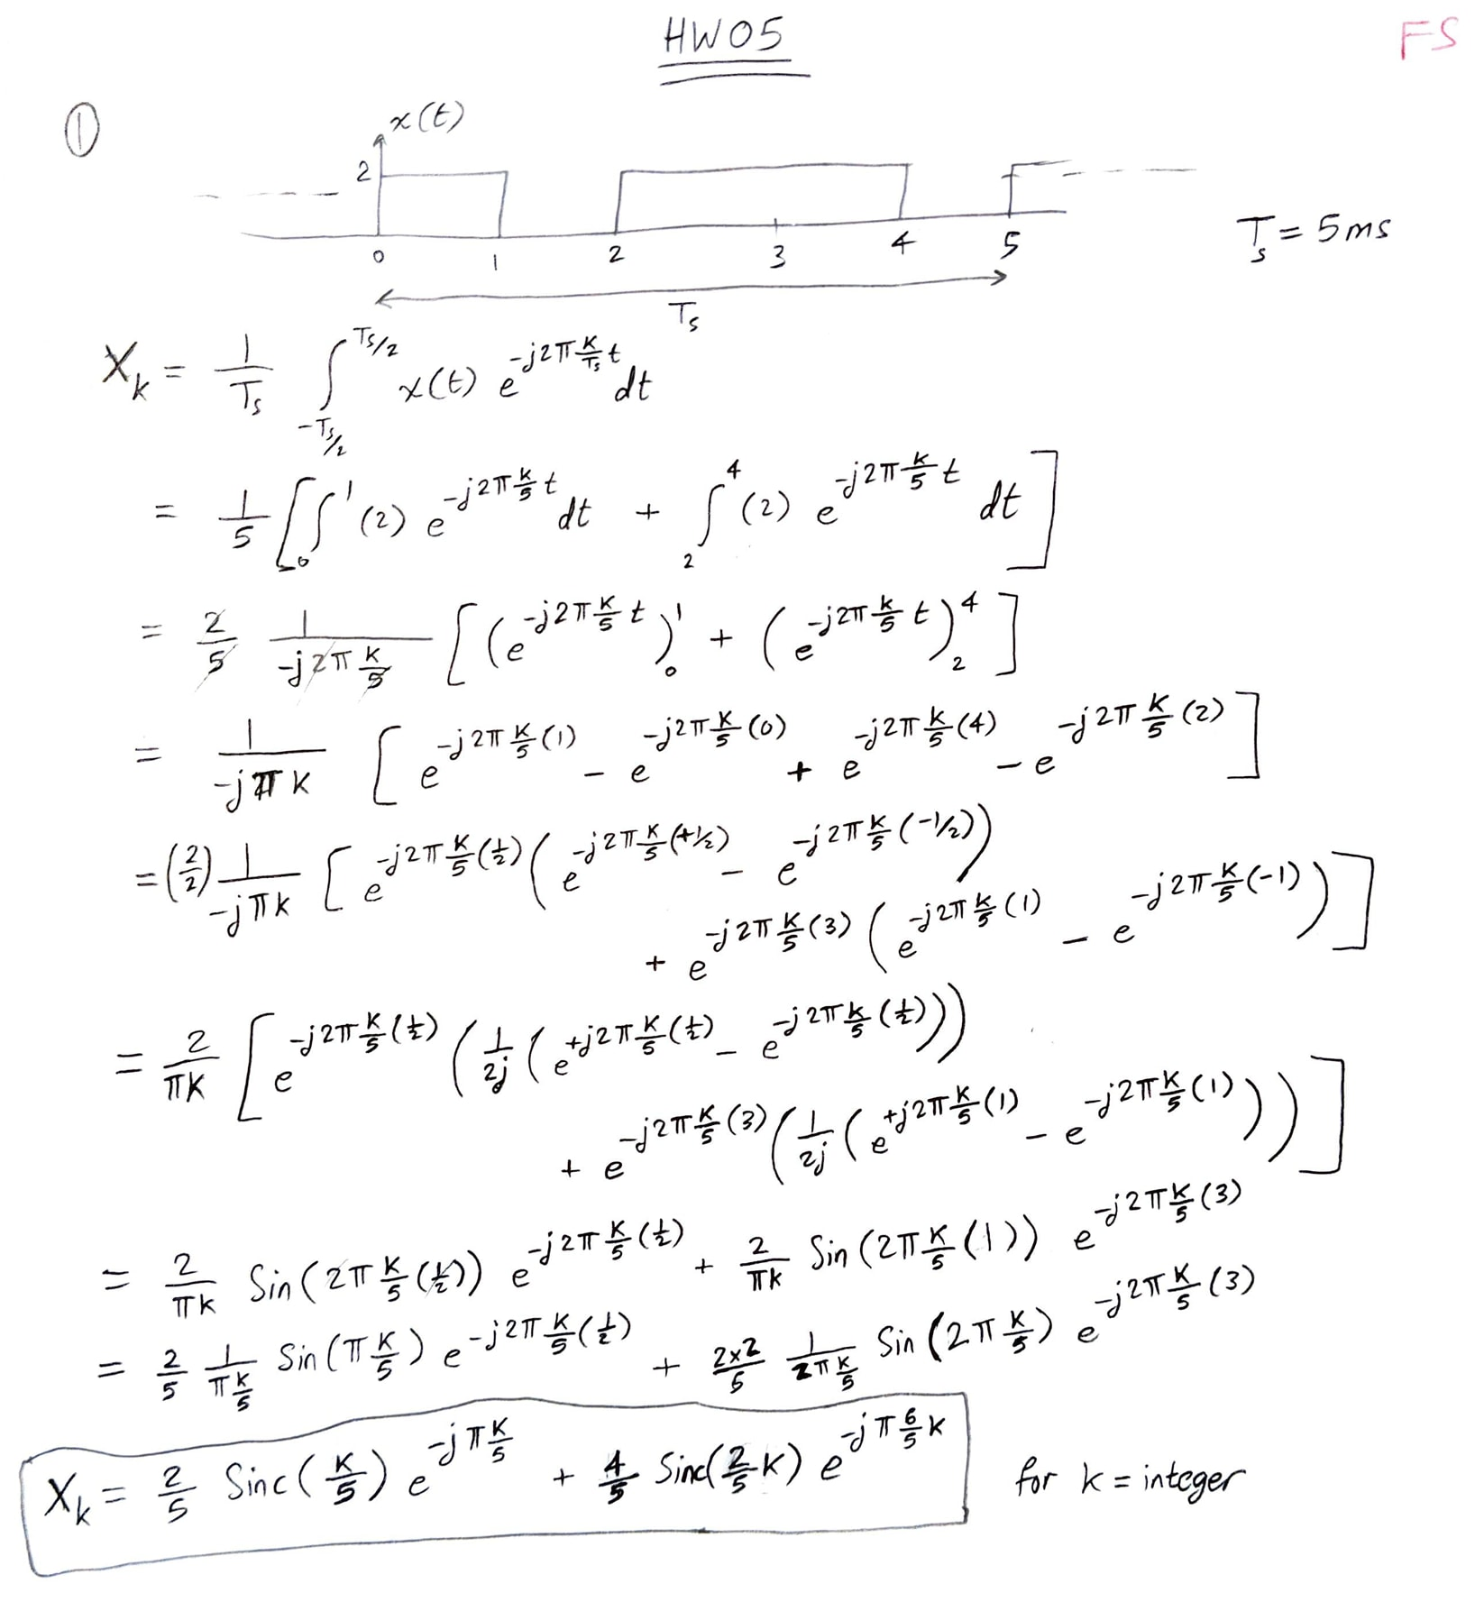

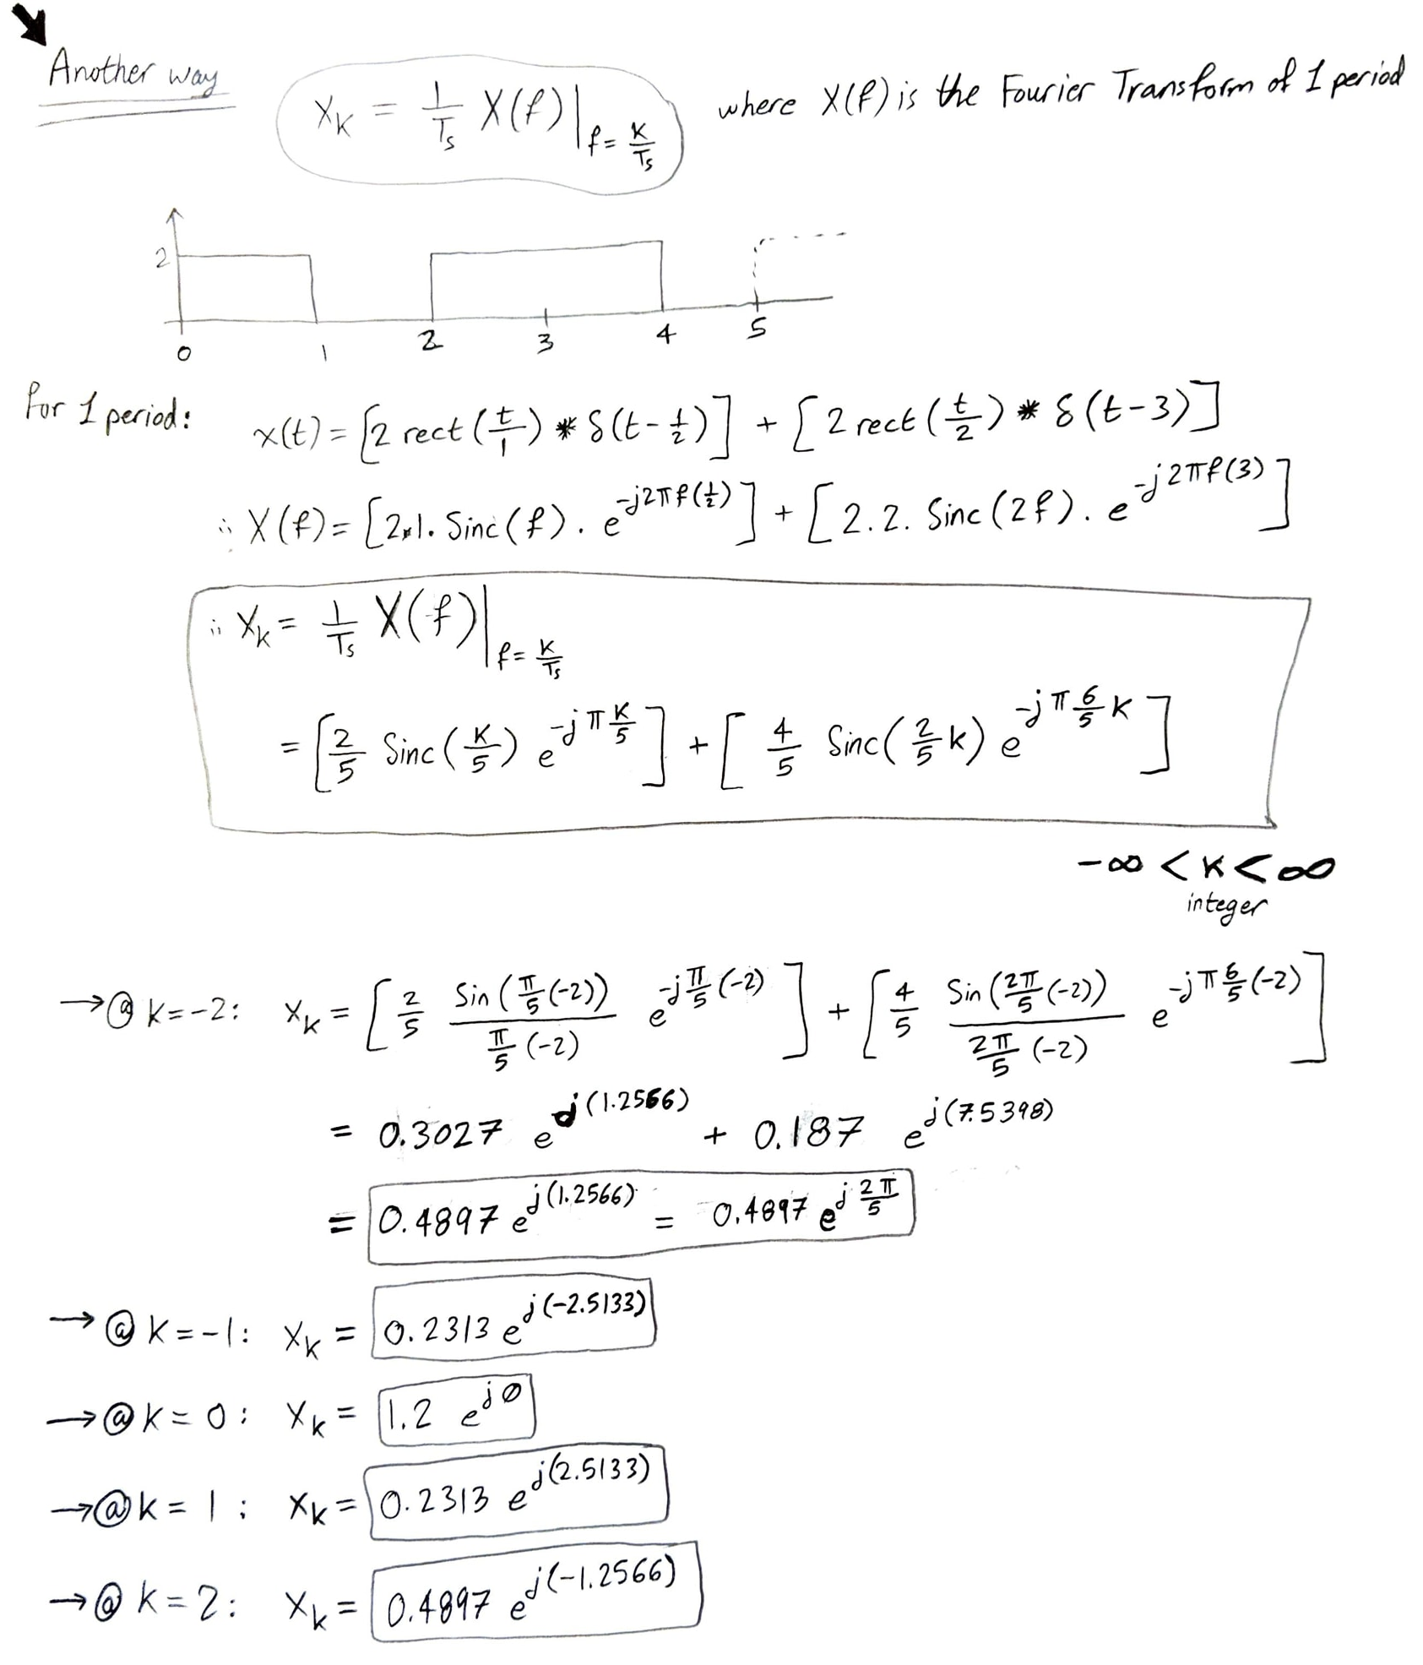

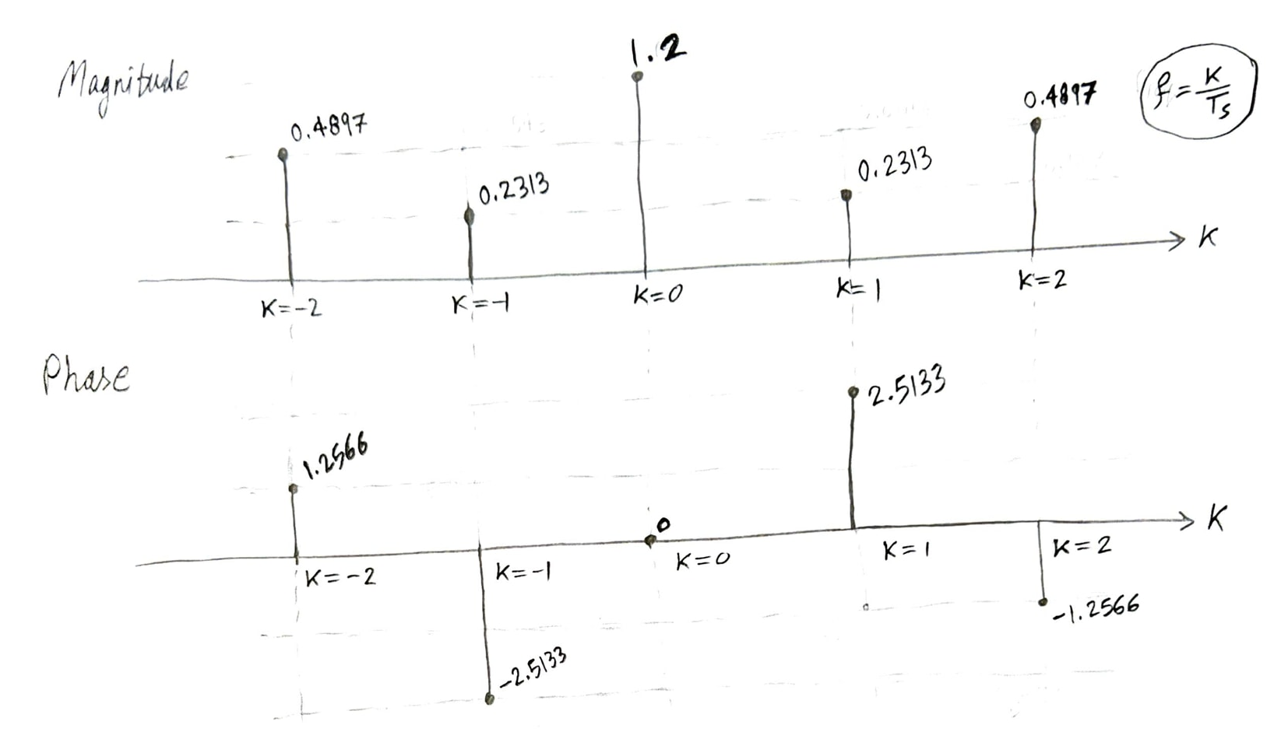

**Q2: Assuming that x(t) is periodic & continuous in time**

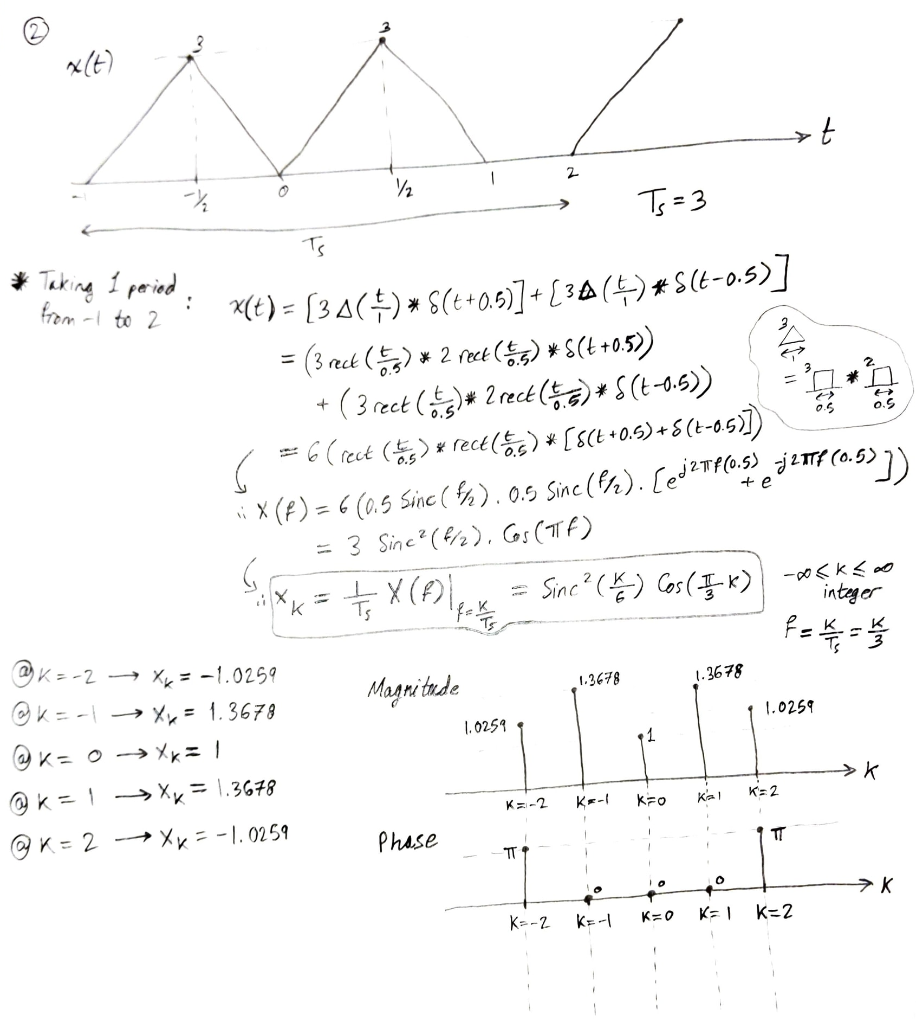

**Q2: Assuming that x(t) is periodic & discrete in time**

